

**Department Of Computer Science**

**National University Of Computer And Emerging Sciences.**

THE DECORUM

Team Members:

Syed Muhammad Aqeel Abbas

17k-3701

Muneeb Ul Hasan

17k-3717

Muhammad Furqan

17k-3836

Sir Fahad Samad - Signature

1. **Abstract**

This enables customers to search, detect and position 3D objects via AR technology in the real environment. This app will address the existing problem by which consumers had to go to showrooms and try to imagine how each product  would fit into their place. However, this our app will allow customers to insert their e-commerce products that looks lifelike into their places before buying the actual furniture.

1. **Motivation:**
2. **Introduction**

E-commerce (electronic commerce) is the ordering and selling of merchandise and services, or the transmitting of funds or data, over an electronic network, primarily the internet. These business transactions occur either as business-to-business ([B2B](https://searchcio.techtarget.com/definition/B2B)), business-to-consumer ([B2C](https://searchcustomerexperience.techtarget.com/definition/B2C)), consumer-to-consumer or consumer-to-business.

Augmented reality (AR) adds digital elements onto a smartphone camera, making an illusion that holographic content is a part of the physical world around you. Augmented reality allows you to virtually try on glasses or see how home objects will look on your table. Such applications must distinguish between the physical and digital world to place virtual objects onto the right area.

1. **Project Background**

The first ever Augmented reality app was created in 1968 by father of computer graphics “Ivan Sutherland” . It turned into an AR head-installed display gadget. From then on AR superior as wearables and digital shows. It could format virtual factors at the actual-international photo, as an instance, show geological information approximately about a selected area. In the year 2008, Augmented reality has opened a way of using augmented reality in industrial purpose. A Garman agency developed an augmented reality application for BMW Mini. To enable it a customer had to point a camera at a printed ad and the model of car auto come alive at the display. The customer could manipulate car on the screen by controlling it and move it around to view at different angles, simply by manipulating the printed image. In the early 2010s Augmented reality introduced that might have interaction with actions in the real world in real time. For that reason, the virtual try on technology has all started by augmented reality’s instant face recognition revolutionized buying experience. Now you can try out anything form virtual making up your face to place a couch inside your home. In 2016, augmented reality (AR) catapulted into the mainstream with the release of Pokemon Go, an AR game that grew to 45 million daily active users after just two months on the market. Since then AR has been adopted in various industries. Let’s take a look at what augmented reality is, the benefits of augmented reality. Augmented reality can be described in somewhere between physical world and virtual world where computer generated images, texts, sounds, animations, videos are layered on the top of the physical view. Users can interact with these elements via application on smartphones, tablets, augmented reality headsets like Microsoft HoloLens, and augmented reality glasses like Vuzix Blade.

1. **Literature Review**

Augmented reality is also exceptionally useful in interior design, as demonstrated by the applications emerging from major retailers of home decor, accessories, and interior design such as IKEA and Lowes. In order to compensate for the lack of flexibility in adoption by the industry, we will illustrate how augmented reality is taking off, how AR applications are used, and how the technology adds value on both the supply and demand sides of the vertical growth of assets.

Improved designs and drawings, of course, are useful in promoting and selling interior design. However, Augmented reality could be particularly useful for marketing developments before they are even completed, as it can realistically visualize how imagined or partially developed projects will look when completed. At some point during this lifecycle, attention turns from form and function to the more aesthetically oriented aspects, like the look and feel of a building’s interior. Here too, augmented reality finds good use, not only by architects, designers, and marketers, but also by those on the demand side.

Whether working with professional interior designers or taking the do-it-yourself approach, property buyers of all kinds can use [real estate software](https://www.iflexion.com/real-estate-software) with AR technologies to experiment with design elements and define how rooms will look before they ever have to commit to choices in coverings, furnishing, or fixtures.

While even mentioning AR tends to conjure images of complex 3D animations springing up from the kitchen table, one of the most professional augment reality apps currently available for interior design platforms a far less grand, yet nonetheless vital function.

1. [**Houzz**](http://www.houzz.com/)

Houzz is great for design inspirations. It has 5 million high-res home images. Interior designers told me that they use Houzz a lot as a tool to figure out what their clients like. Beside their giant pool of nice images, Houzz is building 3D models for its product on its marketplace where you can see products in your room before buying them on Houzz.

Pros: It has 3D models for some products.

Cons: Not so great user experience.

1. [**DecorMatters**](https://itunes.apple.com/app/apple-store/id1168709467?pt=118384149&ct=md&mt=8)

DecorMatters is a new startup focusing on interior design and decorating. The app enables you to design on a template or a real room background. Users have more freedom of choosing furniture from their familiar brands or stores to try. Moreover, they have inspirations where you can purchase all furniture and decorations directly from the design. It’s really shopping the look. They recently have the AR Ruler feature where you can measure your space to see whether the furniture is going to fit into your space or not.

Pros: More brands and products for users to try (Crate & Barrel, West Elm, Living Spaces, etc.) User experience is great; Easy for mood board as well as scratch design.

Cons: don’t have 3D models, sometimes you have to find the right angle of the furniture.

1. [**Homestyler**](https://www.homestyler.com/mobile)

Homestyle has the similar concept as DecorMatters. Their products have 3D models. However, their UX is a little bit hard to use.

Pros: 3D models product.

Cons: Very limited furniture selection; UX is hard to use.

1. [**Hutch**](https://www.hutch.com/)

Hutch was doing great during May, but they’ve changed so much since then. I could not tell where their focus is now. It’s hard to use Hutch to create a design. You have absolutely no control over the furniture position. You will need to wait for 1 hour for your photo to be analyzed in their database before using it as a design background. In all, the experience is terrible.

Pros: Have shadows, and in-app purchase, 3D models.

Cons: Very limited furniture choice. No freedom to choose the furniture position.

1. [**Neybers**](http://www.neybers.com/)

It’s more like a community or a game where you can comment or vote on other designs or take some challenges as a game. It’s fun to interact with other designers in the community.

Pros: Have lighting and shading tools.

Cons: Don’t have 3D models; limited furniture choice.

1. [**IKEA place**](https://itunes.apple.com/us/app/ikea-place/id1279244498?mt=8)

Ikea’s concept video has gone viral on YouTube. It’s neat and fun to watch. I tried their app, and it’s easy to use, and the result is not bad. Not sure why App Store reviews are not that good. The only drawback is you only can select limited products and of course only from IKEA.

Pros: High fidelity 3D models; Great UX experience.

Cons: Limited product selection.

1. [**Pottery Barn 3DRoomView**](https://www.potterybarn.com/pages/3d-room-view/)

Williams-Sonoma purchased Outward for $112 million in cash. I am not sure if the Pottery Barn 3D Room View is all from Outward technology or developed from its own team. In summary, the outcome is not bad, their 3D models have really nice rendered textures. However, I found the UX of the app is a little bit hard to use. They may want to improve on that next.

Pros: Nice 3D models.

Cons: UX is not so good; Limited product selections.

1. [**HouseCraft**](https://itunes.apple.com/us/app/housecraft/id1261483849?mt=8)

HouseCraft is more like a one-time game thing for me. First of all, it only has 38 furniture products in total. OK. Fine. Plus 13 accessories if that counts. Second, their 3D model quality is not that good compared to IKEA and PotteryBarn. So based on these two points, it’s really fun to play with it a little, but you definitely can’t really do any creative design out of it.

Pros: Nice UI/UX flow. Have fun stuff like tornado and gun effect.

Cons: Very limited product selection. No capability of doing a photo background design.

1. [**iStaging**](http://www.istaging.com/)

iStaging is very interesting. It has a few products in 3D model, but not a lot. The fidelity of their models is good. They also have a few designs where you can apply directly to your camera or view them in VR mode. However, you can’t really create your own design by selecting different furniture on the same scene. You can only view one furniture at one time.

Pros: High fidelity 3D models; VR mode.

Cons: limited products selection & design. Can’t create any design, only view product in AR mode.

1. [**SayDuck**](http://www.sayduck.com/)

SayDuck has limited product inventory too. And I don’t know where their database is, their app is slow. Loading a product to your screen takes about several minutes! It would be a much better experience if they can boost their database performance or reducing their model size.

Pros: 3D model; UI is simple.

Cons: Very slow; limited products choice.

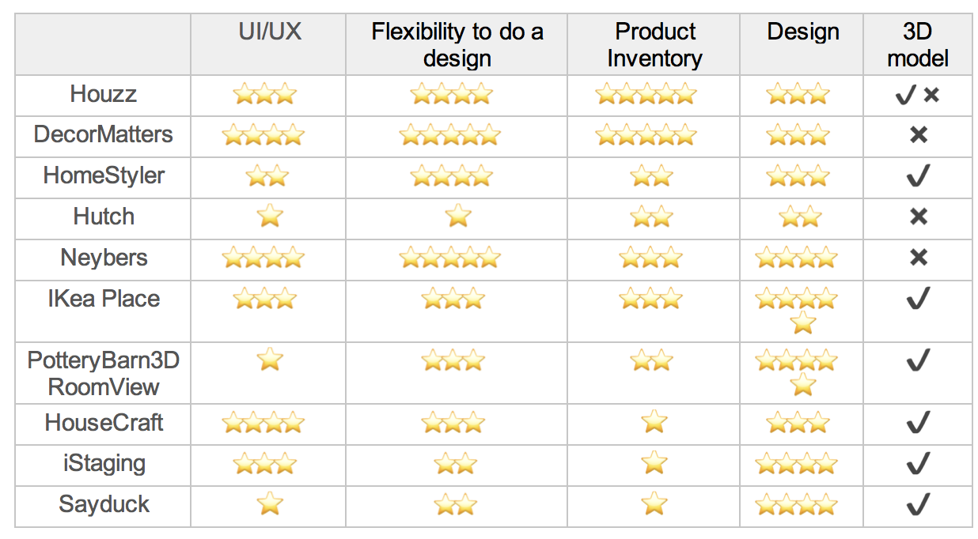

1. **Proposed Methodology/Architecture**

As our project is linked with another project, the first thing that we will do is that we will make an app which will be fetching data to our app from the database of the other project. Then if the customer searching on the web wants to see the product via AR, there will be an option beside the product on the web, like (“Click to check this product on AR”), then from there our Application will open on customers mobile, app will first ask the customer for permission to open camera, then the customer can check out the product by placing it anywhere he/she likes in his/her room. Customer can also check out the sizes in which that product is available, suppose if the customers selects a vase of medium size than the order of selected size will go towards the web and from there customer can check out.

For a new customer, not coming directly from the Web Button but installing our app directly from Play store. The App will first ask permission of camera and then the app will open. He will see a list of items that our currently available on the web. If he wishes to check out the product, he can click on it and see details or he can check that product in AR and then checkout towards the web to further process the order. There will also be buttons of login and signup which will redirect users towards web and from there they will be able to login or make a new account.

**In scope features of our Application:**

* 3d Object Tracking.
* Able to select angle of product.
* Take pictures while using AR.
* Share pictures.
* Select available color.
* Select available size.
* Search items.
* Click on product to see details of it on web.

**If time:**

* Recommendation of products (product having highest sale will be shown to users).

1. **TOOLS:**

* AR SDK: MAXST or Vuforia or ARCore or ARToolKit or Kudan or Viro
* Front-End: React Native
* Back-End: Firebase/Node Js

1. **Work Breakdown Structure**

THE DECORUM

Redirect to Web App to Register/Login

Open Camera

Redirect to App

Checkout Products

Checkout on Augmented Reality

Save as a Picture / Share Picture

Order

Redirect to Web to Confirm Order.

1. **Deliverable of both Project-1 and Project-2**

**Project 1:**

In Project-1 we will be making an application which will only be showing interface of how will app our look after the connectivity of database from the web (other project).App will be asking the permission for camera and we will insert dummy products for FYP-1 to show how users will be able to see products that will be on the web after the connectivity from the database which will be done in FYP-2.

**Project 2:**

In Project-2 we will be connecting our application with the database of web (other project) and then our application will consist of products that are available on the web.

After connecting with the database, we will then integrate AR in our application so that the customers can check the product via AR and be able to make choice by seeing the product by placing it in real life and make online shopping hassle free.

1. **Proposed Timeline for FYP-1 and FYP-2(Gantt chart)**

1. **References:**
2. Maxst.com. 2020. [online] Available at: <http://maxst.com/#/en/arguide> [Accessed 16 October 2020].
3. Google Developers. 2020. *Quickstart For Android  |  Arcore  |  Google Developers*. [online] Available at: <https://developers.google.com/ar/develop/java/quickstart> [Accessed 16 October 2020].
4. "Augmented Reality App Development - A Guide To Getting Started". 2020. *Waracle*. <https://waracle.com/blog/augmented-reality/introduction-augmented-reality-app-development/>.
5. "Best AR SDK For Development For Ios And Android". 2020. *Thinkmobiles*. <https://thinkmobiles.com/blog/best-ar-sdk-review/>.
6. "The Rise Of Augmented Reality In Interior Design And Property Development". 2020. *Iflexion*. https://www.iflexion.com/blog/augmented-reality-interior-design.